**ELE 639 Lab 3: Control of Servo-positioning Module**

**Summary:**

In this lab, we implemented different types of the controller to examine the control of a servo-positioning module. A PID controller was tuned to improve the performance of the closed-loop system and the servo was adjusted to meet desired transient and error response specifications. In part 1, an uncompensated proportional-only controller with unity gain was used. A nominal range was considered, with some specifications for amplitude and phase angle. When output was 50 degrees, the dead zone became apparent, as the system reached saturation. This shows that P only control was unable to produce a linear invariant system since the settling time was not close to what was expected.

In part 2, we changed the system gain to different values to improve the tracking of the servo module, with a compensated P and PID controller. We noticed that increasing gain decreased the steady-state error and the rise time, but the PO and settling time increased. We implemented the Ziegler-Nichols “Ultimate Gain” Method to finally determine the specs using the modified method formulas, for Kp, Ti and Td. We noticed that the settling time and error decreased for the PID controller. The Anti-windup controller caused the PO to be decreased. However, the steady state error was increasing, thus PID was chosen.

For part 3, the non-linear effects of saturation were examined as the system moved out of the nominal range, in terms of its amplitude of the input. We observed a large change for the uncompensated systems, due to saturation for an input pulse of 300 degrees. It was obvious that in the nominal range, the compensated system had better settling time and rise time when compared to the same systems in the saturated regions. The anti-windup decreased the PO again, but with the addition of rising time, settling time, error and settling time this time. For an input of 20 degrees, the uncompensated system had an improved PO while the compensated demonstrated better rise time, settling time and steady-state error. Moreover, the PIDA controller had a higher rise and settling time, but had a zero state response.

**Part 1: Uncompensated Servo Module Response**

1. The response of the uncompensated servo system in the nominal range is as follows:

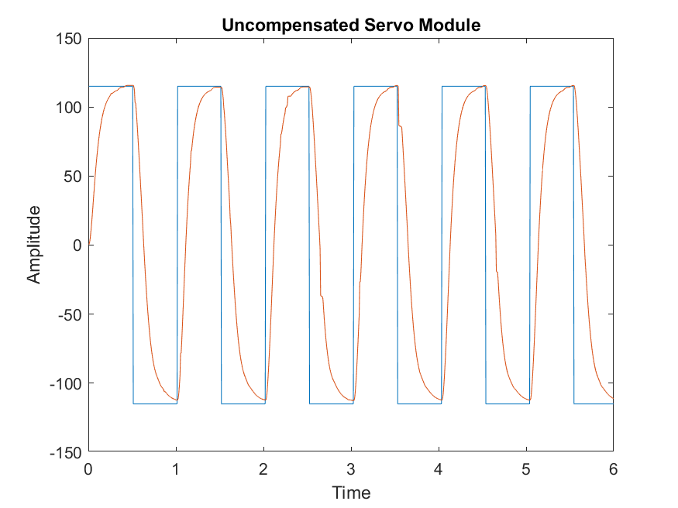 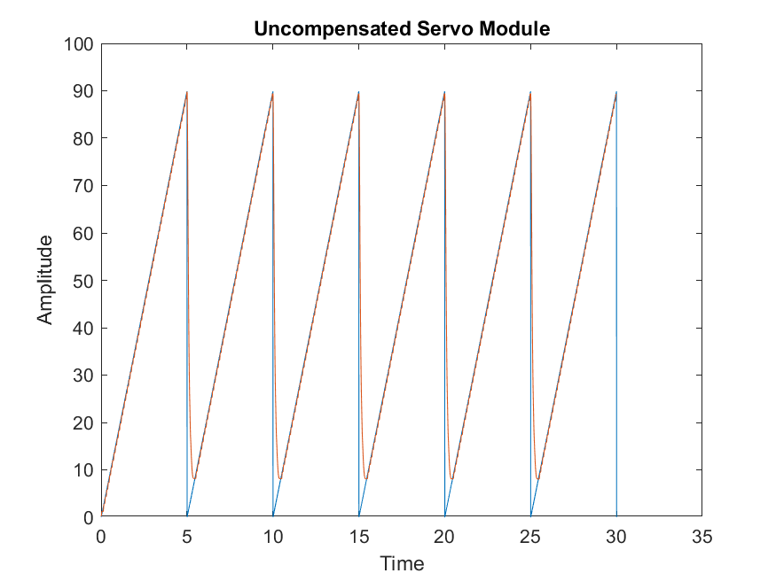

**Figure 1.1: Uncompensated Servo (Square Wave) Figure 1.2: Uncompensated Servo (Ramp)**

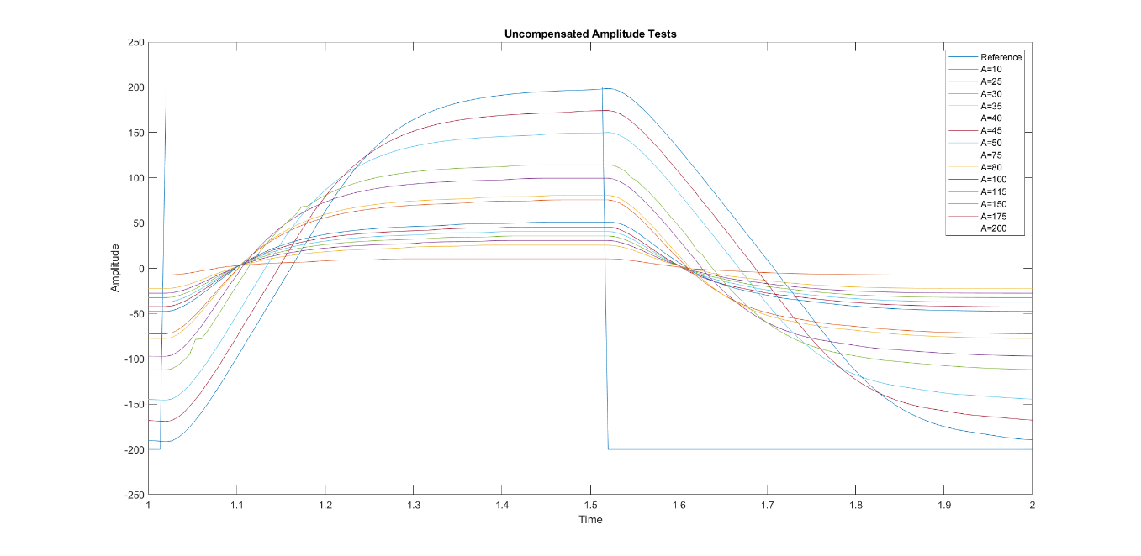

**Figure 1.3: Uncompensated Servo Amplitude Test for A = 10 to A = 200**

1. The nonlinearities present in the square wave response are evident just by observing Figure 1.1 above. The errors are a result of only implementing a Proportional controller. However, when a PID controller is being implemented, the main proportion of control is handled by the Proportional controller.
2. The nonlinearities are caused by the dead-zone effect, as it is evident just via observation. Tweaking the Kp value adjusts the effects on the system. Since a P controller is being used, the gain is the only adjustable parameter and thus makes it a limiting factor towards making nonlinearity too difficult to accomplish.
3. Below is a table comparing the results achieved from both part 1 with an uncompensated as well as PID from part 2.

Table 1.1: Parameters for Uncompensated Proportional and Compensated PID Control

|  |  |  |  |  |  |
| --- | --- | --- | --- | --- | --- |
| **System Type** | **PO (%)** | **Settling Time (±2%) (s)** | **Rise Time (10-90%) (s)** | **Steady State Error (Step) (%)** | **Steady State Error (Ramp) (%)** |
| **Uncompensated P Control** | 0 | 0.0002 | 0.1533 | 1.1336 | ∞ |
| **Compensated PID Control** | 5.06 | 0.0001 | 0.0667 | 1.0506 | 0 |

1. The system type is a Type 0, as it is evident by observing the step and ramp response of the system. The steady state error of the system response backed the system type. In Type 0, the steady state error of the positional gain is always a constant value. The step and ramp response conform to the expected values for Type 0. This is corroborated by the values in Table 1.1. Also, a system Type 0 has an infinite steady state error unlike Type 1 which has a constant ramp response.

**Part 2: Compensated Servo Module Response**

The first section of this part of the lab comprised of analyzing the proportional controller by incrementing/decrementing the gain value. The following plots exhibit the result of the system tracking under different gain values.

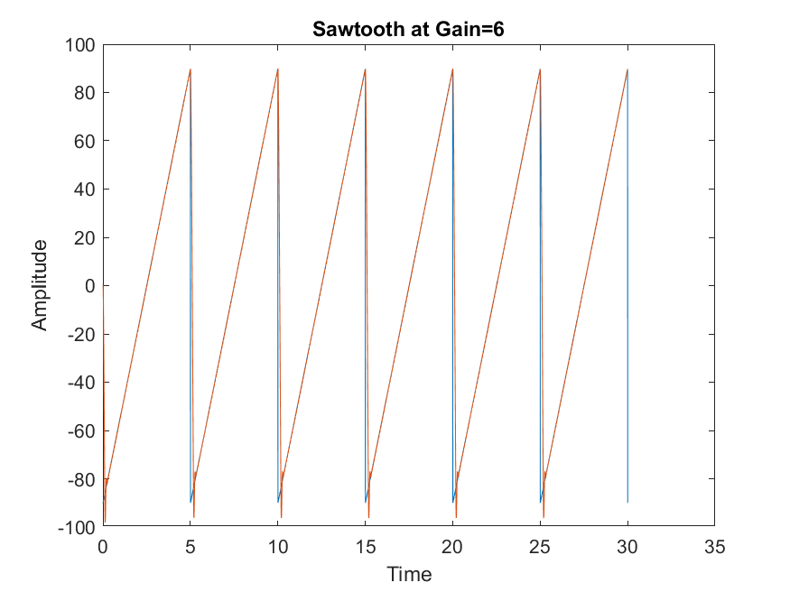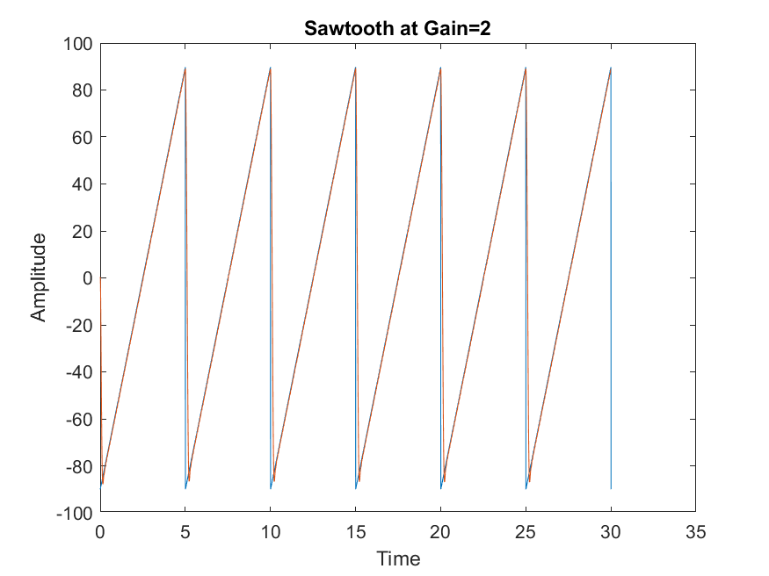

**Figure 2.1: Sawtooth at Gain = 1, 2, 2.5 & 6 under Proportional Controller**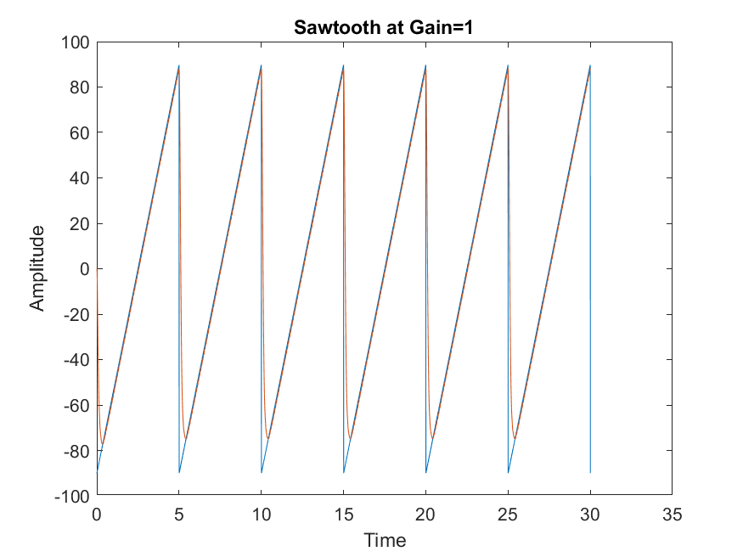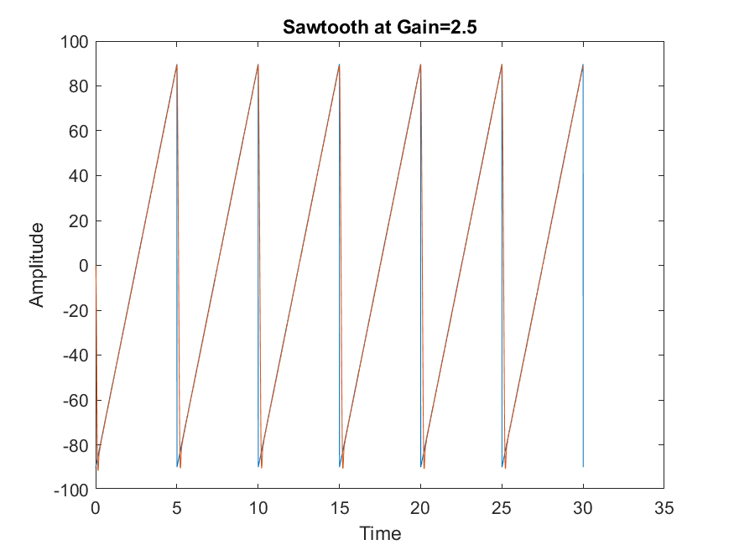

**Figure 2.2: Square wave at Gain = 1, 3, 4 & 6 under Proportional Controller** 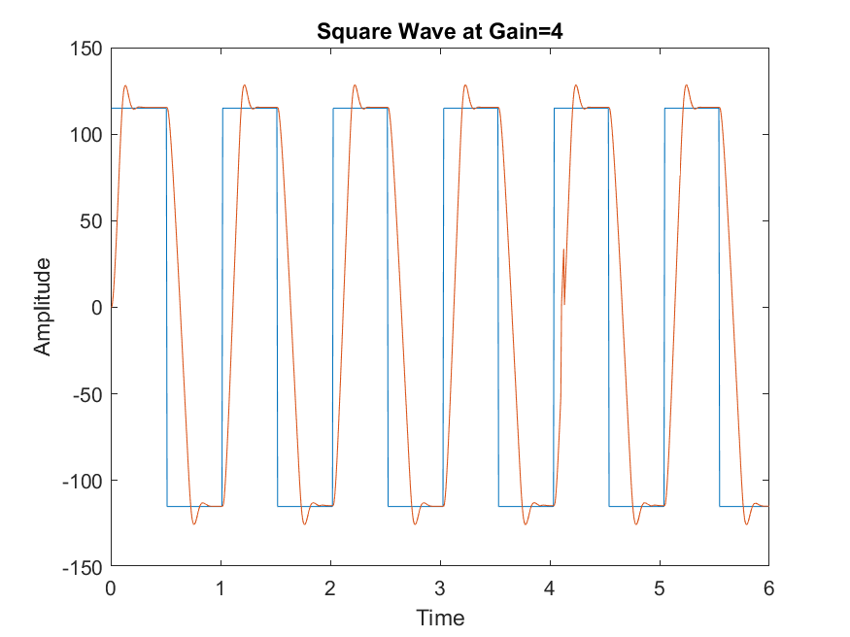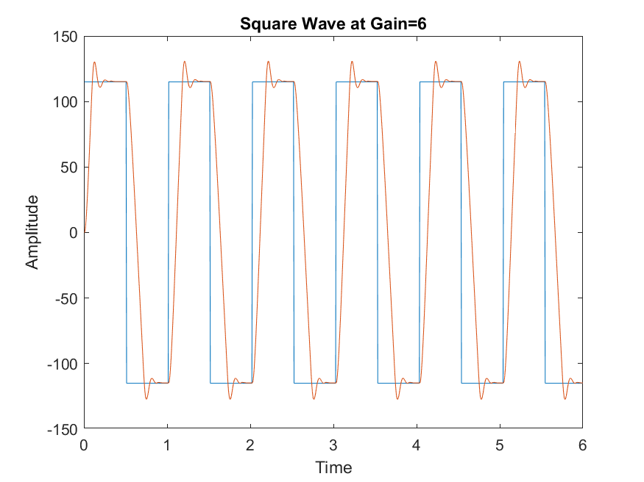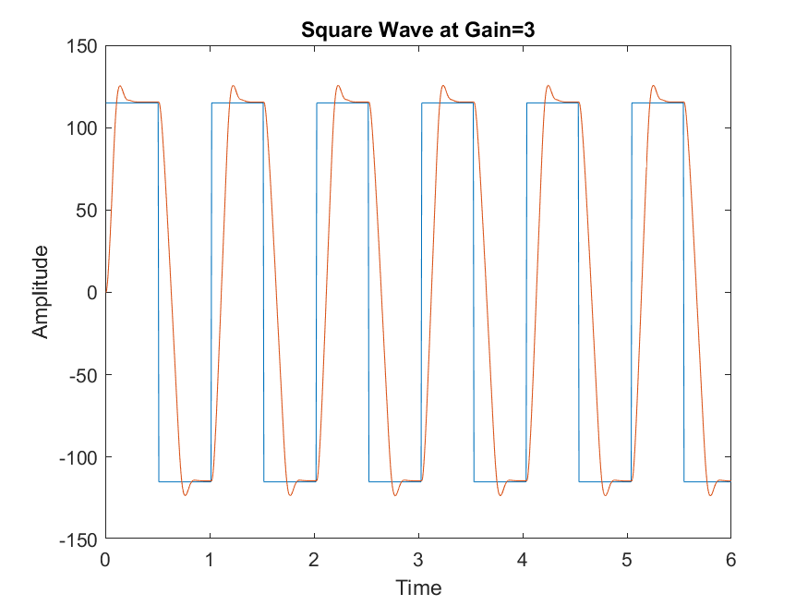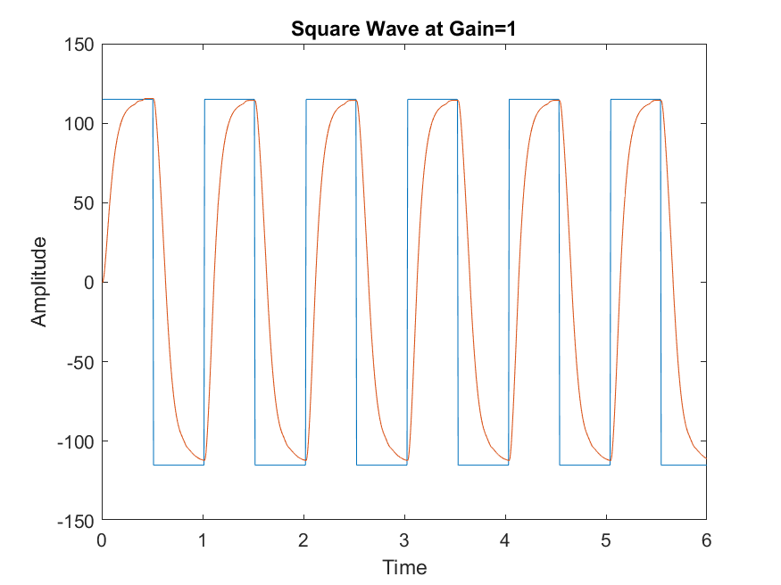

By observing the plots in Figure 2.1 and Figure 2.2, it seems that the steady state error and the rise time decreases as the gain increases. This also affects the percentage overshoot as with an increase in gain, the percentage overshoot increases as well. As the system reaches marginal stability due to the tweaking of the gain value, the nonlinearities in the system will become evident. Since the system type is 0, the proportional controller was not able to meet all the system specifications. The best value, therefore, for the proportional controller was taken at gain = 6.

**Figure 2.3: Ideal Response under PID controller for both Ramp and Square Input**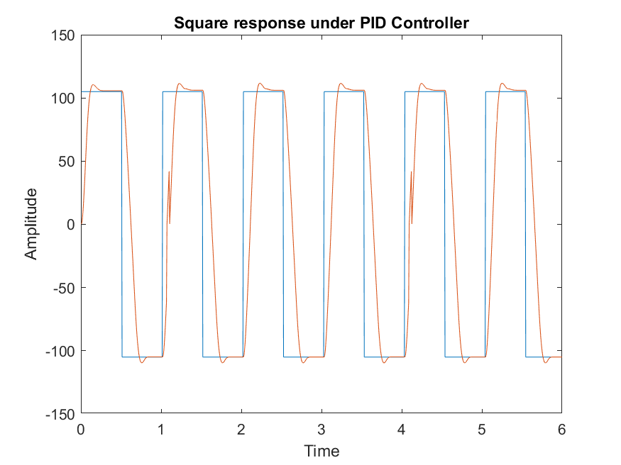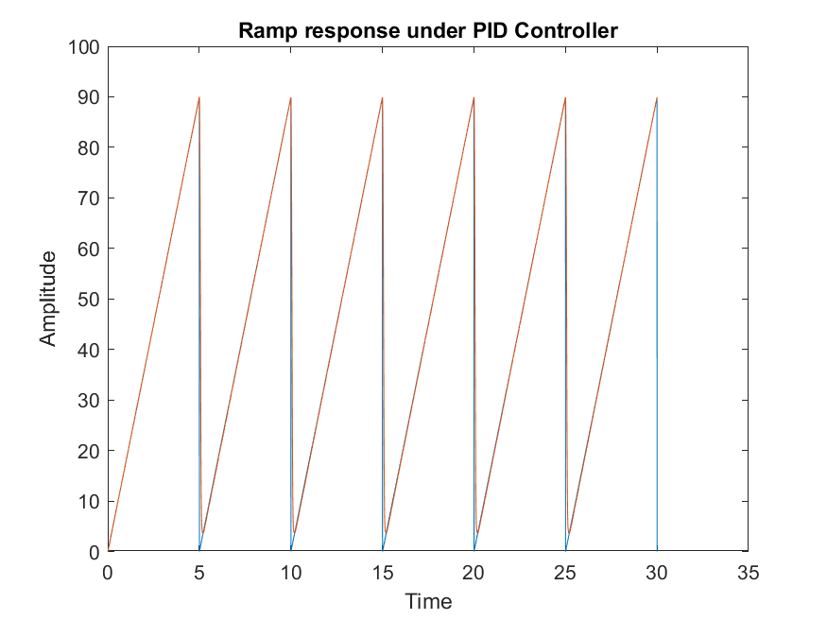

The ideal response for both the ramp and the square input were acquired via trial and error. Implementing the PID+A controller led to the conclusion that it was quite like the PID controller. The integral time and the derivative time constant used were 1.7 and 0.02 respectively.

Discussion:

1. The differences between the Proportional only and PID controller were significant. Unlike the Proportional controller, the PID satisfied the desired specifications in the lab fairly well. The percentage overshoot, as well as the time taken to reach steady state, was decreased in PID. Additionally, the ramp input for the Proportional controller would diverge but with PID, it remained constant since the system now is Type 1.
2. The Ziegler Nichols Ultimate gain method was used to process the PID parameter Kp,Ti and Td using the modified method formulas. The controller had a 115-degree step input, and a marginally stable gain was found that was taken as 6, as shown in Figure 2. The period of oscillation was taken measured from the graph and was found as 0.05 seconds (from 385.40 seconds to 385.35). Using these values, the rest of the parameters were determined for the PID controller using the following equations:

K= 0.6Ku Ti = Pu/2      Td = Pu/6

1. The Anti-windup controller turns the integrator of the servo-positioning module off to avoid the apparatus to get damaged, as the system is already in the saturation mode. This prevents the percent overshoot to be very high as the transient response initially would be high if the buildup of energy in the integrator can be reflected in the system, due to saturation. Therefore, the anti-winding system caused the percent overshoot to decrease slightly without affecting other parameters. The controller was not in saturation mode during the nominal range was chosen, which is why a small difference in Percent Overshoot is noticed.
2. The final settings that resulted in the ‘best’ response were with Gain = 6, Ti = 1.7 and Td = 0.02.

5) Present the "best possible" response of your compensated servo system in the nominal range. How did you adjust the controller parameters to ensure the compensated system response is as close to being linear as possible? Compare the uncompensated specs with the “best” Proportional Control and with the “best” PID Control settings.

**Figure 7: Compensated and Uncompensated P and PID step responses**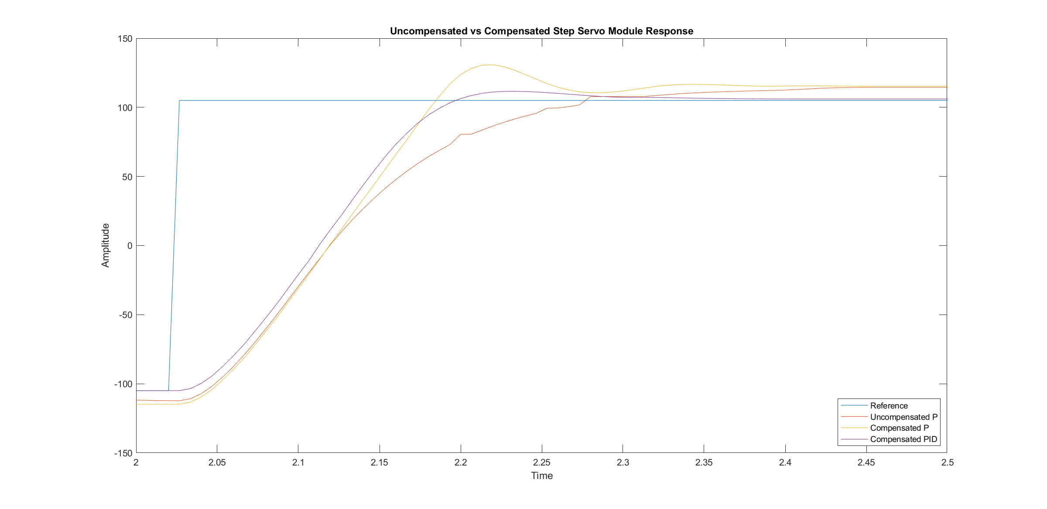

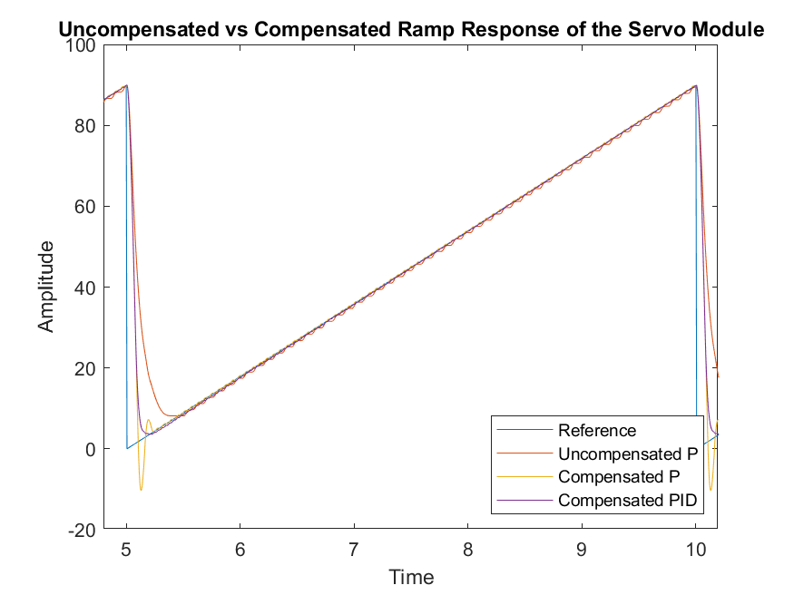

**Figure 8: Compensated and Uncompensated P and PID ramp input responses**

The Zeigler-Nichols Method was used to find the best possible response to the compensated servo module. The parameters were then adjusted to get as close to a linear response as possible. The specifications close to the requirements are outlined in the table below:

Table 2: Performance specifications for the uncompensated and compensated P and PID servo system

|  |  |  |  |  |  |
| --- | --- | --- | --- | --- | --- |
| **Performance Specifications** | PO(%) | Settling Time tsettle(±2%) | Rise Time trise(10-90%) | Steady State Error ess(step)% | Steady State Error  ess(ramp) |
| **Uncompensated Servo** | 0 | 0.0002 | 0.1533 | 1.1336 | ∞ |
| **Compensated Servo (P Control)** | 13.42 | 0.0001 | 0.0600 | 1.1430 | ∞ |
| **Compensated Servo (PID Control)** | 5.06 | 0.0001 | 0.0667 | 1.0506 | 0 |

6) Discuss the improvements in the system response under P, then PID (or PID+A) Control, as compared to the uncompensated system. Consider both the steady state tracking (i.e. discuss the steady state errors) and the transient performance.

We noticed that the anti-windup controller (PIDA) setting improved the square wave input, although the rise and settling time decreased slightly.

**Compensated Servo Module Response outside the Nominal Range- Part 3**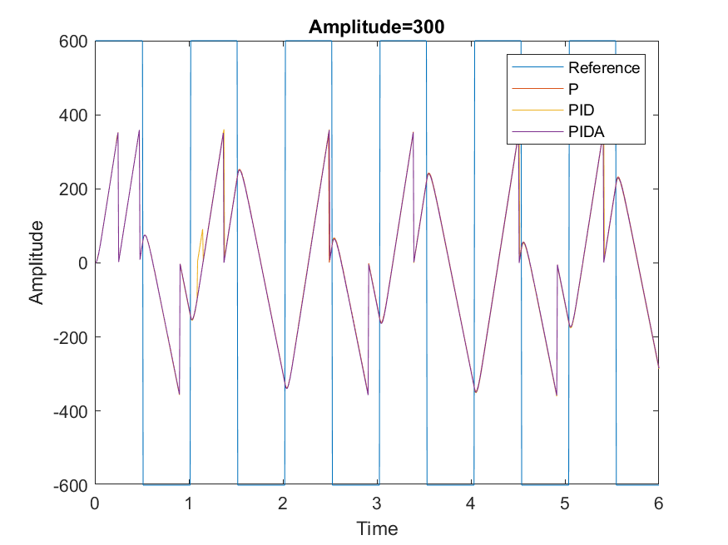

**Figure 9: Servo output with Square wave with an amplitude of 300 degrees for P, PID and PIDA**

***Table 3****- Step response characteristics of saturated systems*

|  |  |  |  |  |
| --- | --- | --- | --- | --- |
| **System** | PO | TRise(10-90%) | Tsettle(±2%) | ess(step)% |
| **Uncompensated P** | 699% | 0.02 | 0.0025 | 58.85 |
| **Compensated PID** | 740.84% | 0.02 | 0.0025 | 60.34 |
| **Compensated PIDA** | 775.95% | 0.02 | 0.0025 | 58.34 |

The performance of the two kinds of systems depicted similar percentage overshoot with close steady-state error, while the rise and settle time were slightly better for the compensated system, in terms of the required performance specifications aforementioned in the lab.

The uncompensated system demonstrated better rise time, settling time but higher percentage overshoot in the nominal range, compared to the saturated system above. The compensated system had better PO, faster rise and settling time, demonstrating zero steady-state error response. 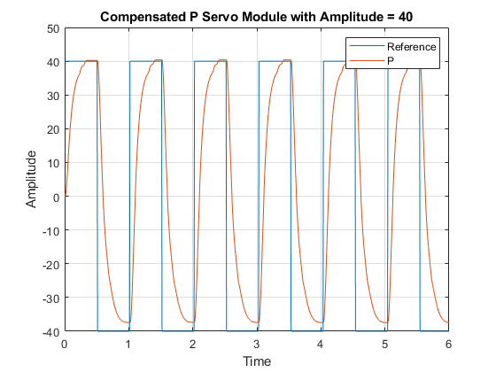

**Figure 12: Servo Response for square input with amplitude of 40 for P**

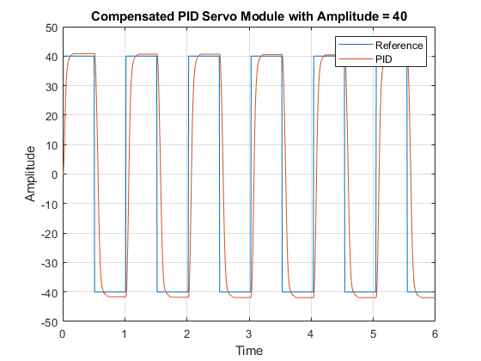

**Figure 13: Compensated Servo Response for square input with amplitude of 40 for PID**

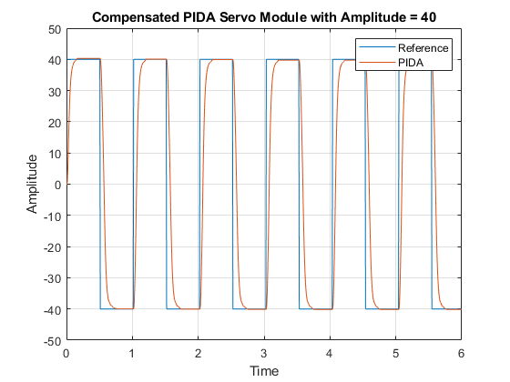

**Figure 14: Compensated Servo Response for square input with amplitude of 40 for PIDA**

Comparing the effects of the amplitude being 10 for the square wave input, it was seen that the uncompensated system hit the dead zone while the compensated, does not.

***Table 4****- Step response specifications of systems operating outside the nominal range (±20°)*

|  |  |  |  |  |
| --- | --- | --- | --- | --- |
| **System** | Percent overshoot | TRise(10-90%) | Tsettle(±2%) | ess(step)% |
| **Uncompensated P** | 0% | 0.1867 | 0.0014 | 3.94 |
| **Compensated PID** | 0% | 0.0533 | 0.0012 | 3.96 |
| **Compensated PIDA** | 0.025 | 0.0533 | 0.0012 | 3.90 |

**Conclusion**